**How to use your Application ?**

to use your react app open your first terminal in the« **scheduler** » folder and run this command.

**npm start**

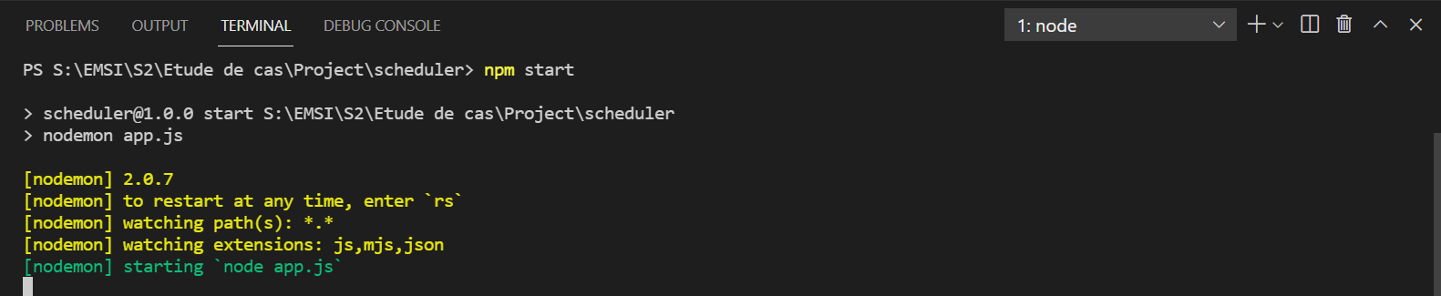

then open the second terminal and run the second command in « **frontend** » folder :

**npm start**

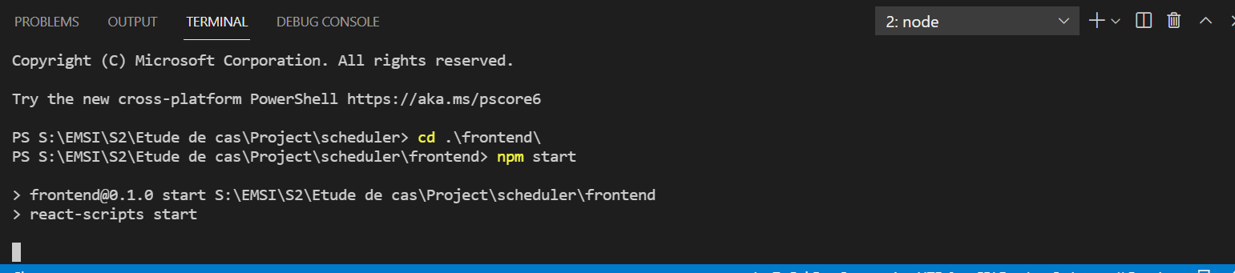

you'll have your react app ready to use with the login interface (« **Log** **in** »).

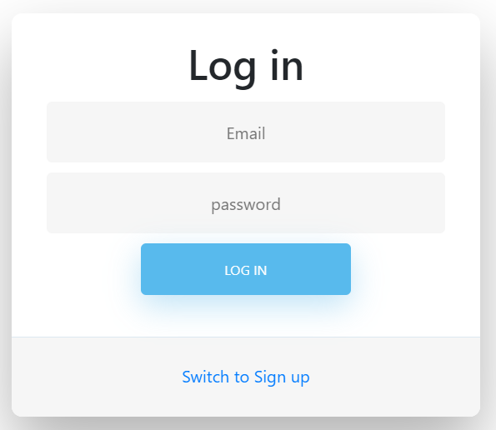

you can consult the existing events by navigating to the events tab « **Events** ».

or you can stay on the same page



if you don't have an existing account click the « **Switch to Sign up** » button and create a new one

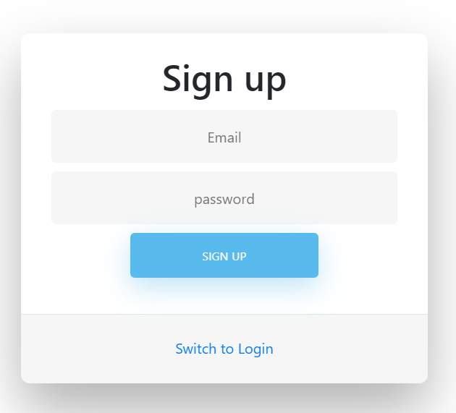

You can go back to the login by clicking « **Switch to Login**»

enter your valid credentials and wait for the « **Authenticate** » button to disappear

click on events tab « **Events** » on the navbar to see the available events created by other users

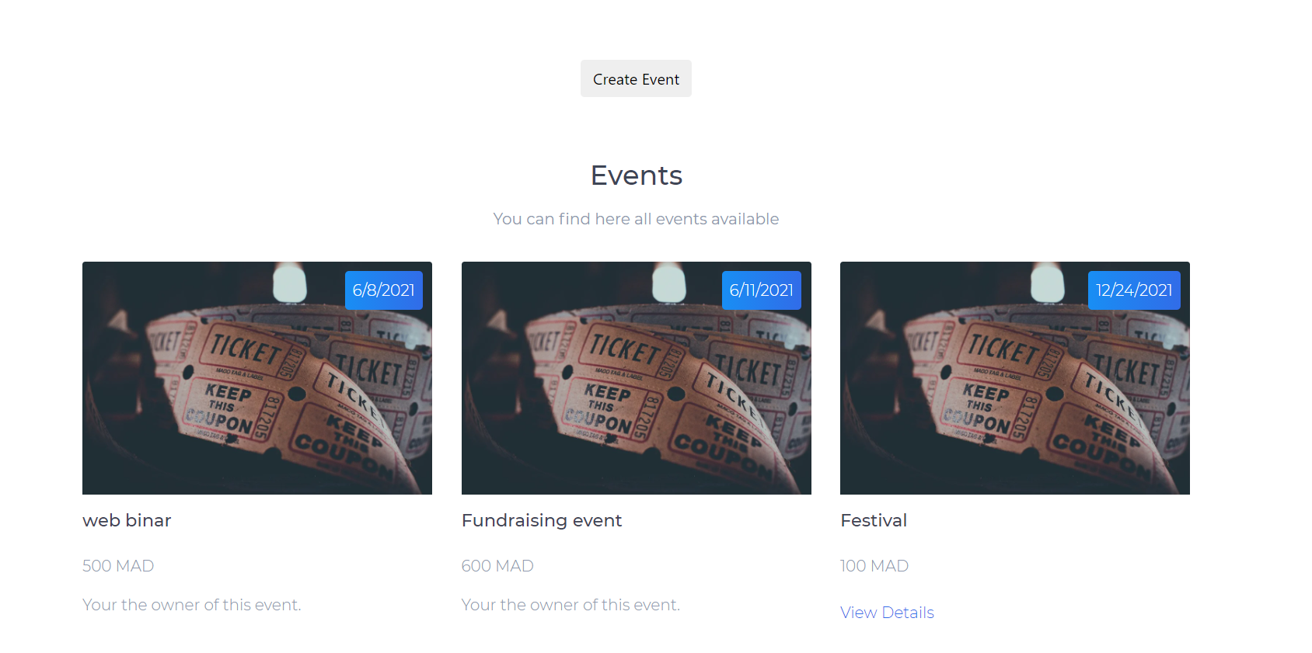

you can « **Book** » an event from the existing events or you can create a new one by clicking the « **Create Event** » button

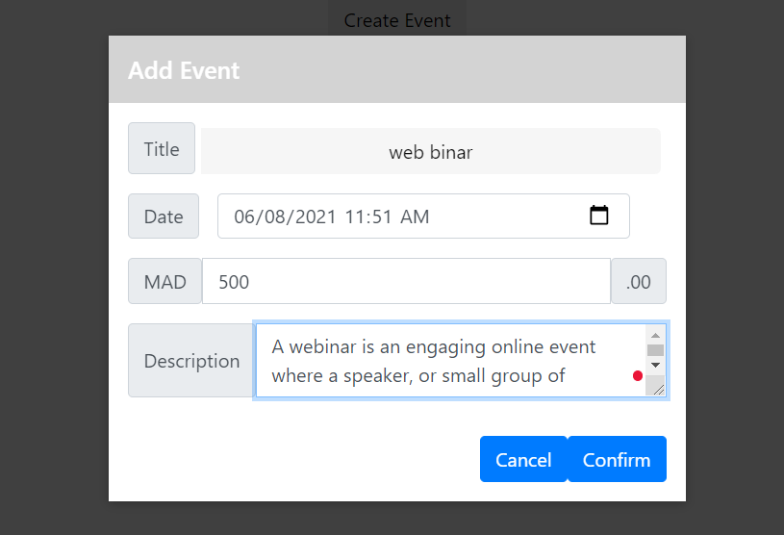

after creating a new event it'll be marked so you can know which event the current user « **Created** »



You can book an event by clicking the « **View details** » and then « **Book** » button

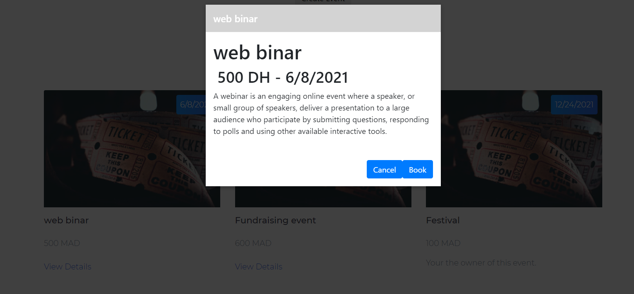

after « **Booking an Event** » it'll be added to the « **Booking** » interface where you can see all your bookings

Or you can « **Cancel** » a booking

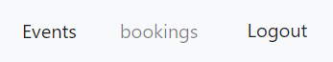

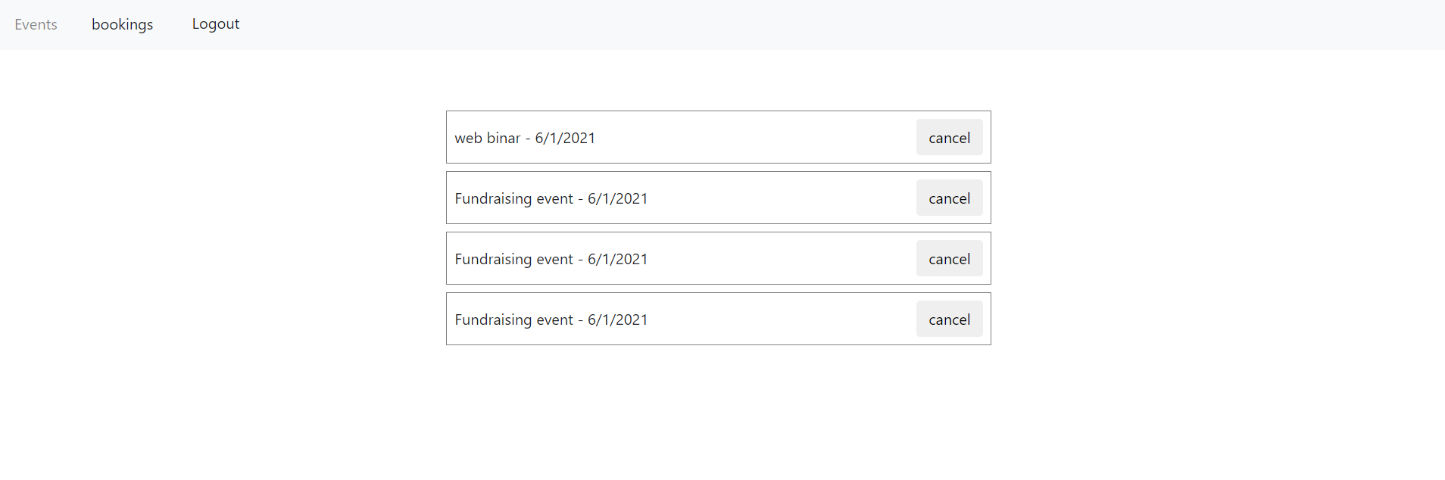

and finally you can logout by clicking the « **Logout** » button in the navbar

